Module Name: Automation Exercise
Test Case ID: 2
Webpage URL: https://www.automationexercise.com/signup

Scenario ID: 1
Scenario: Valid registration
Test Steps:
1. open registration page
2..Enter name
3. Enter email address
4. Enter Password
5. Click sign up Button
Screenshots:
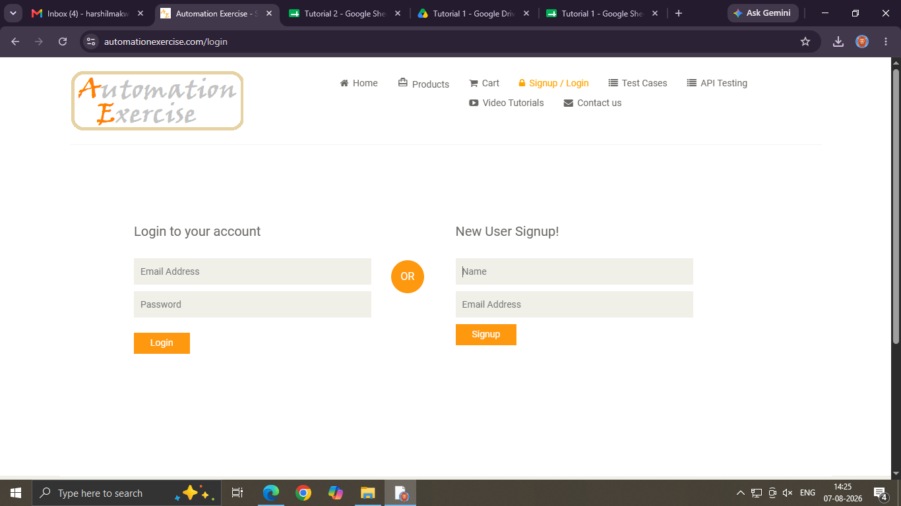

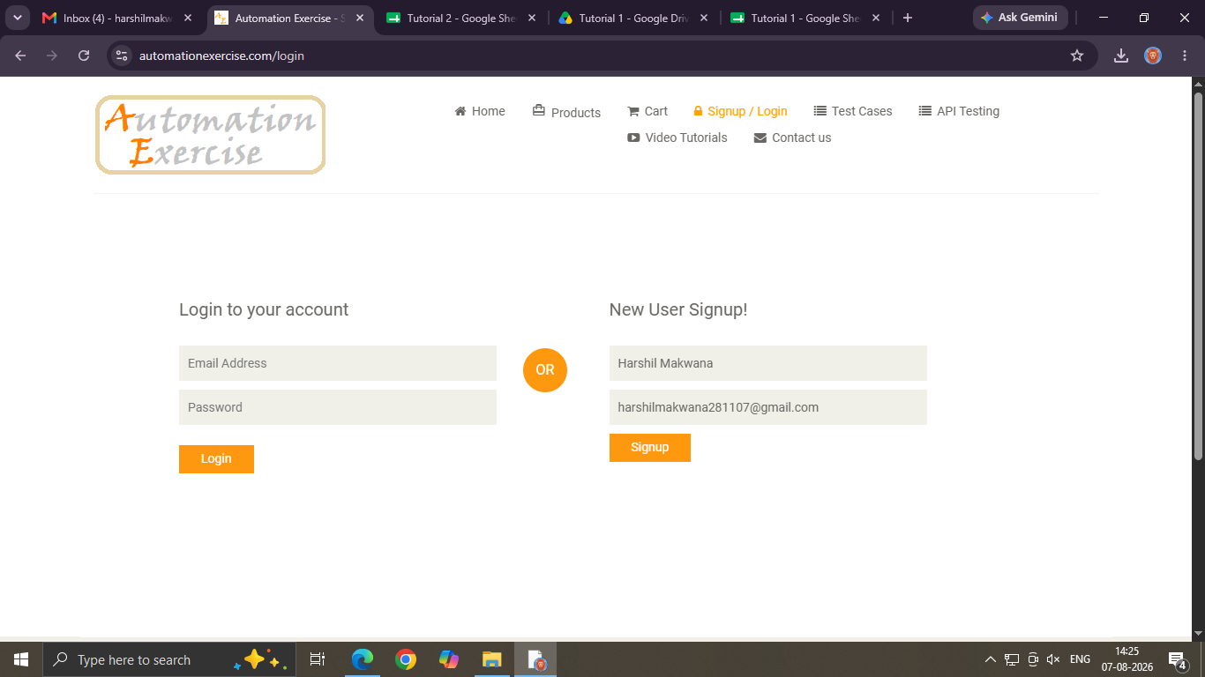
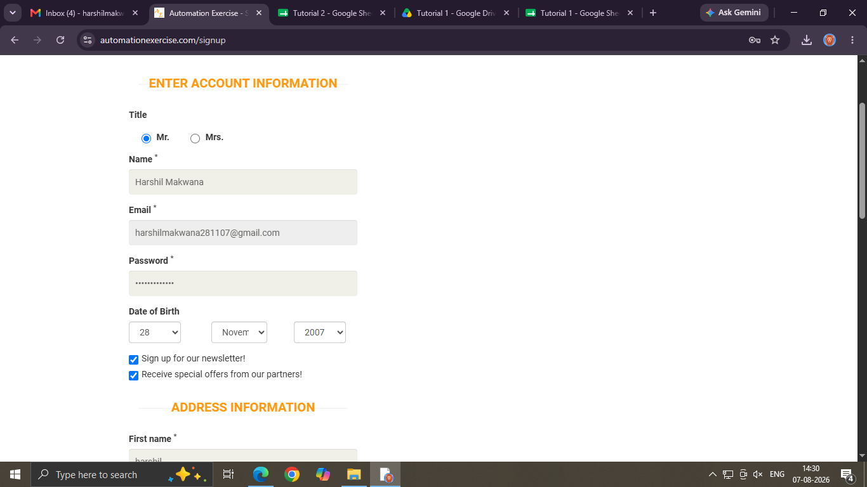

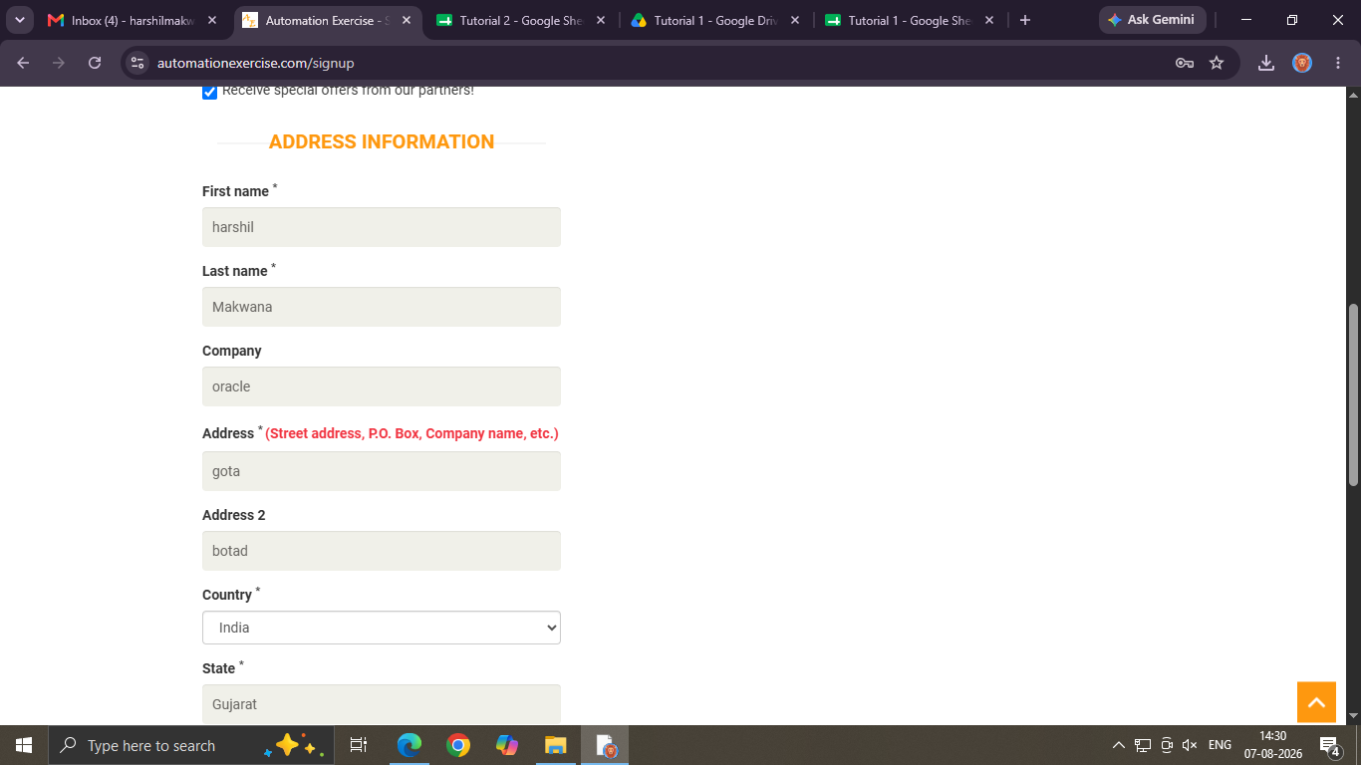
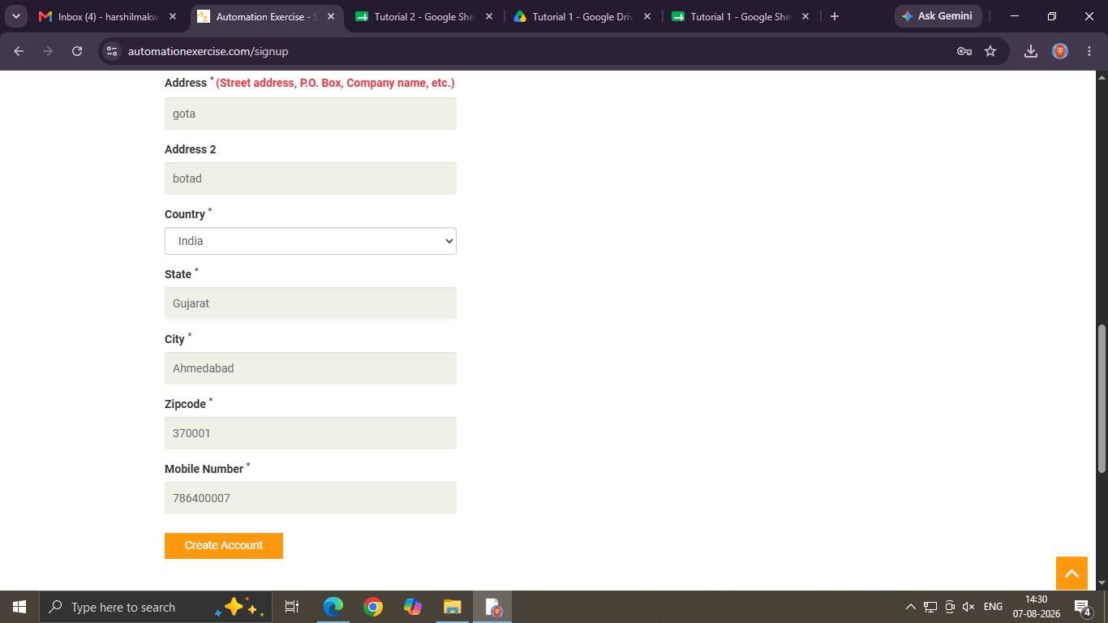

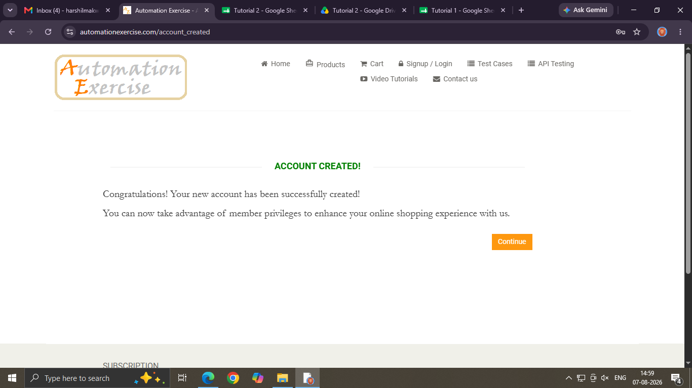

Scenario ID: 2
Scenario: InValid registration
Test Steps:
1. open registration page
2..Enter name
3. Enter email address
4. Enter Password
5. Click sign up Button
Screenshots:
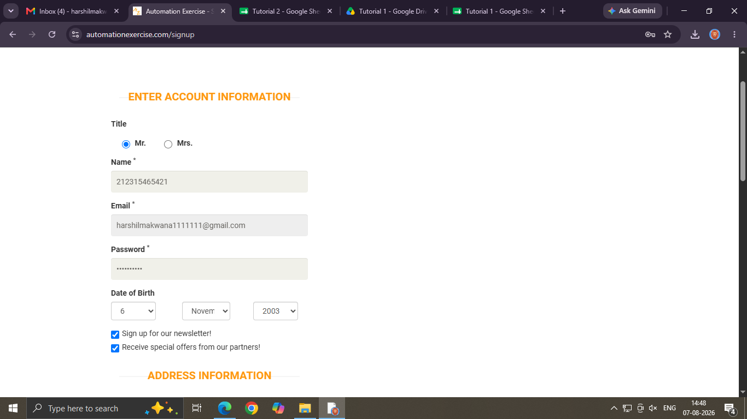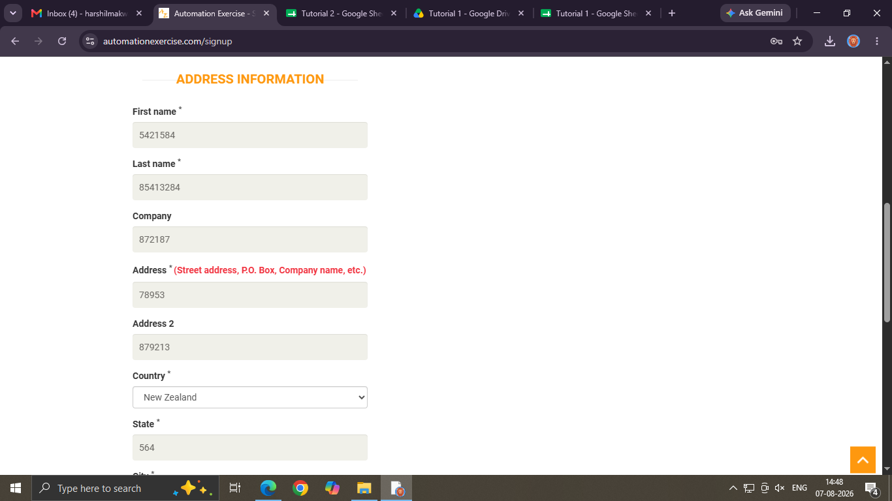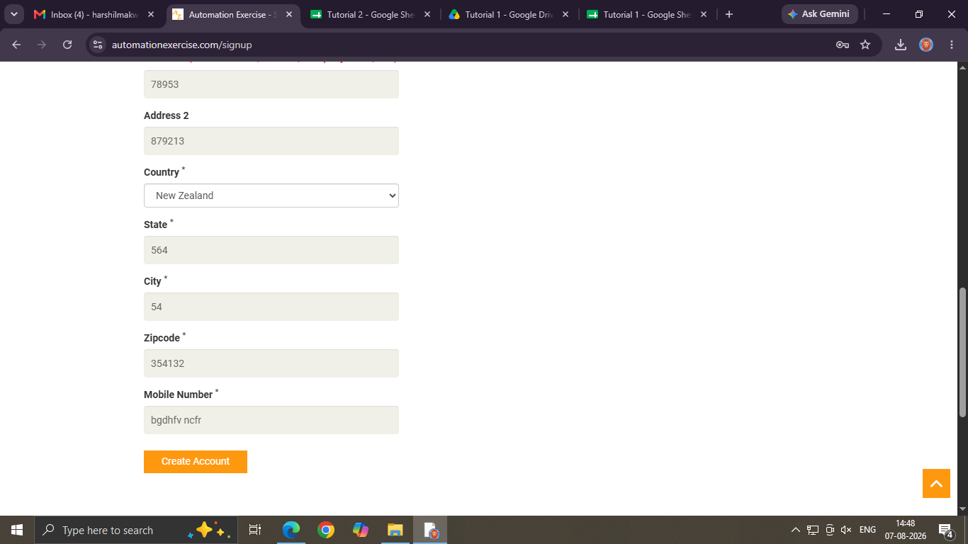

Scenario ID: 3
Scenario: Existing email registration
Test Steps:
1. open registration page
2. Enter already registration Email id
3. Click Signup button
Screenshots:
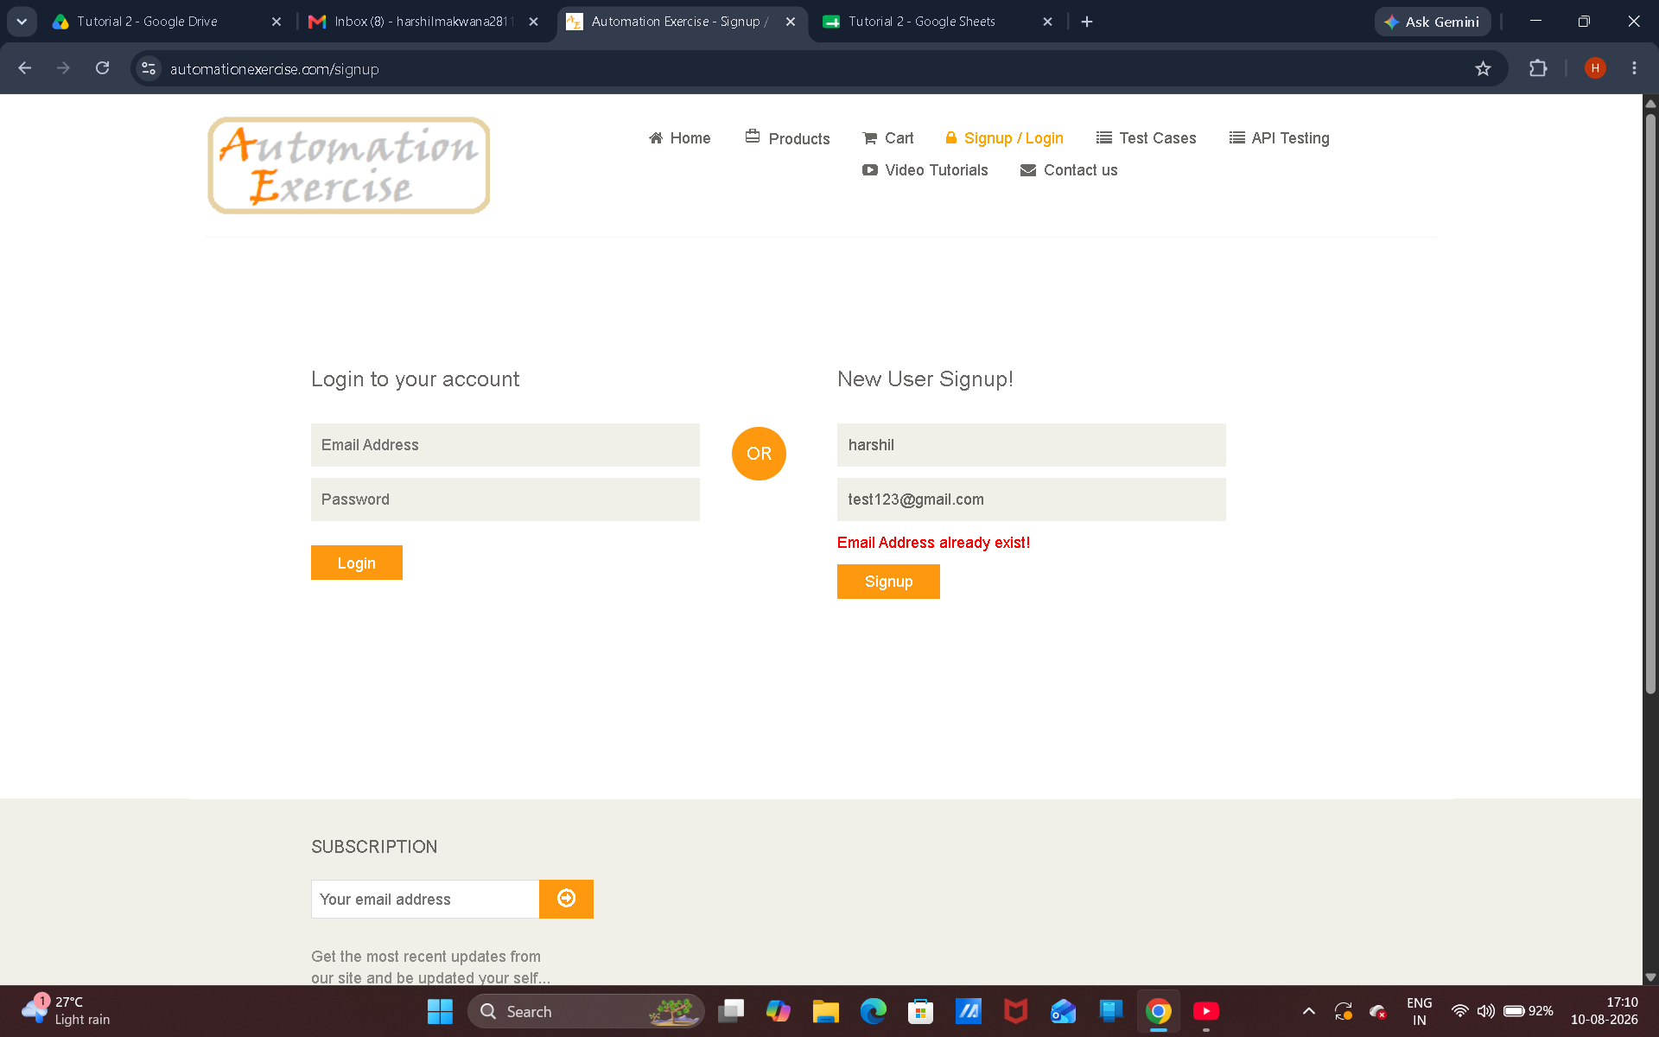

Scenario ID: 4
Scenario: Valid login
Test Steps:
1. Open Login page
2. Enter email id
3. Enter password
4. Click Login button
Screenshots:

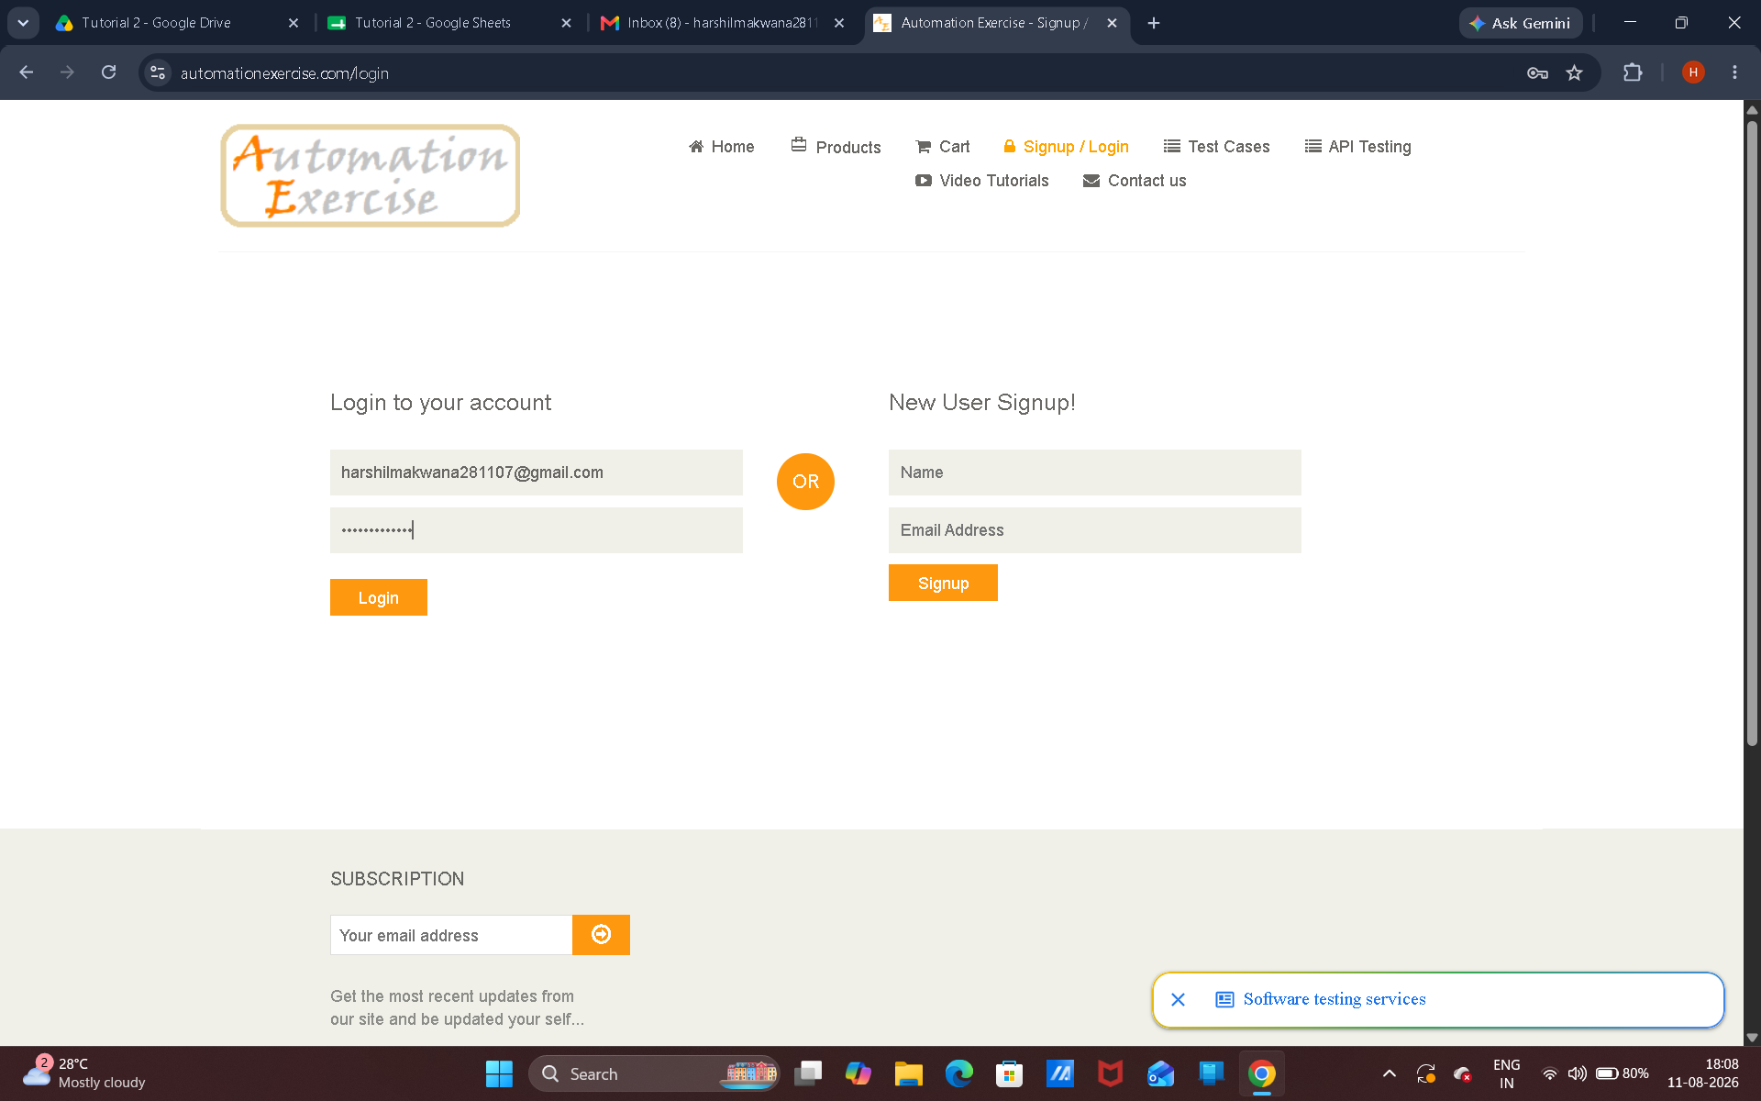

Scenario ID: 5
Scenario: Invalid email
Test Steps:
1. Open Login page
2. Enter email id
3. Enter password
4. Click Login button
Screenshots:
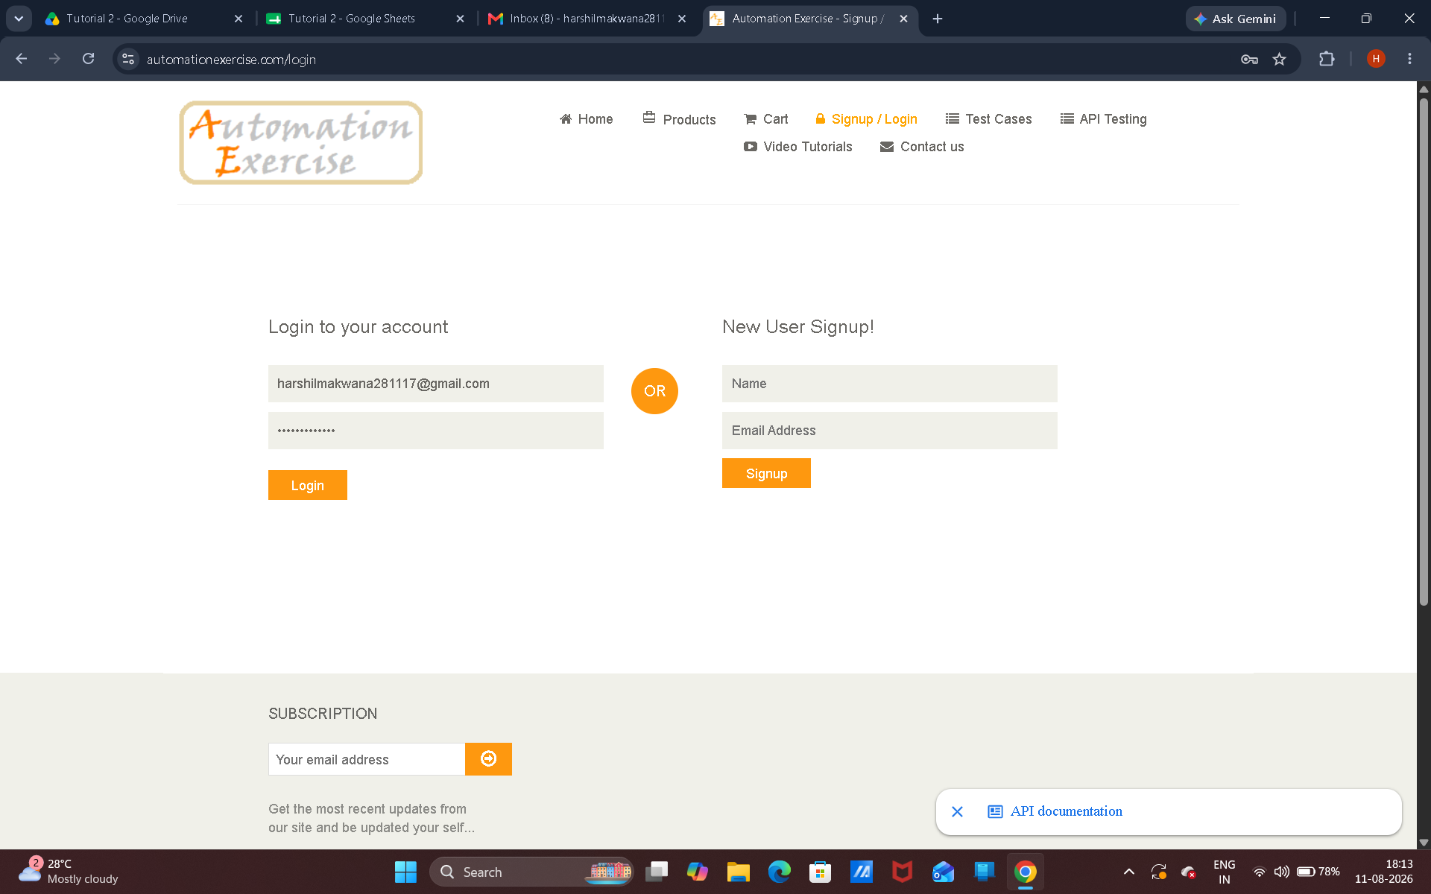

Scenario ID: 6
Scenario: Invalid password
Test Steps:
1. Open Login page
2. Enter email id
3. Enter password
4. Click Login button
Screenshots:
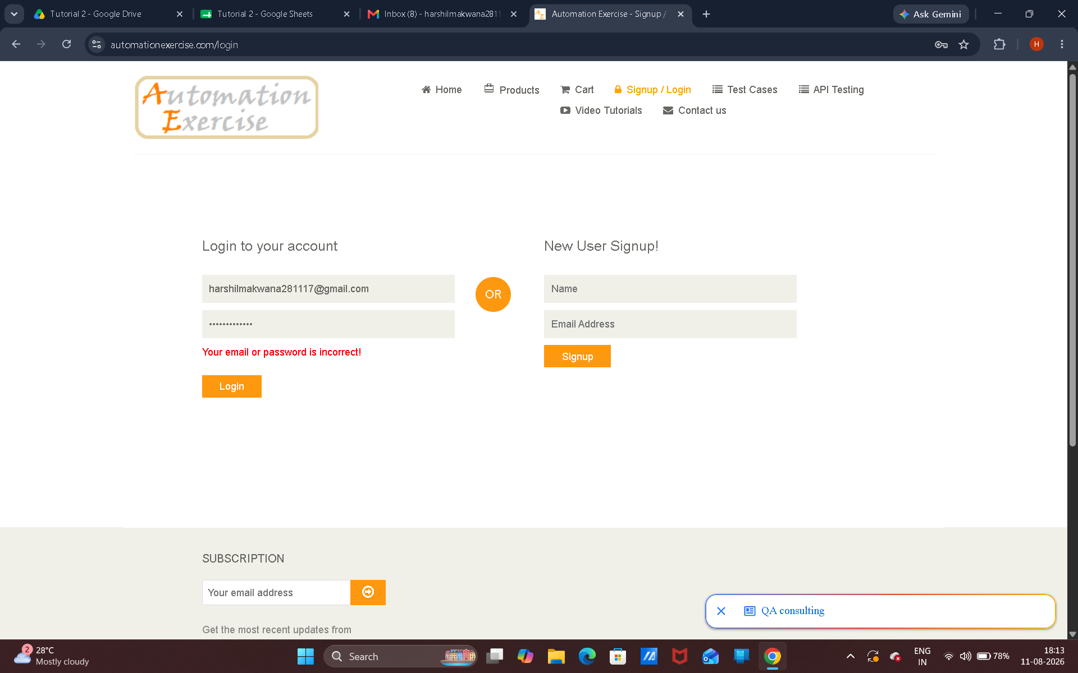

Scenario ID: 7
Scenario: Blank username
Test Steps:
1. Open Sign up page
2. Not Enter Username
3. Enter Email id
4. Click Sign up button
Screenshots:
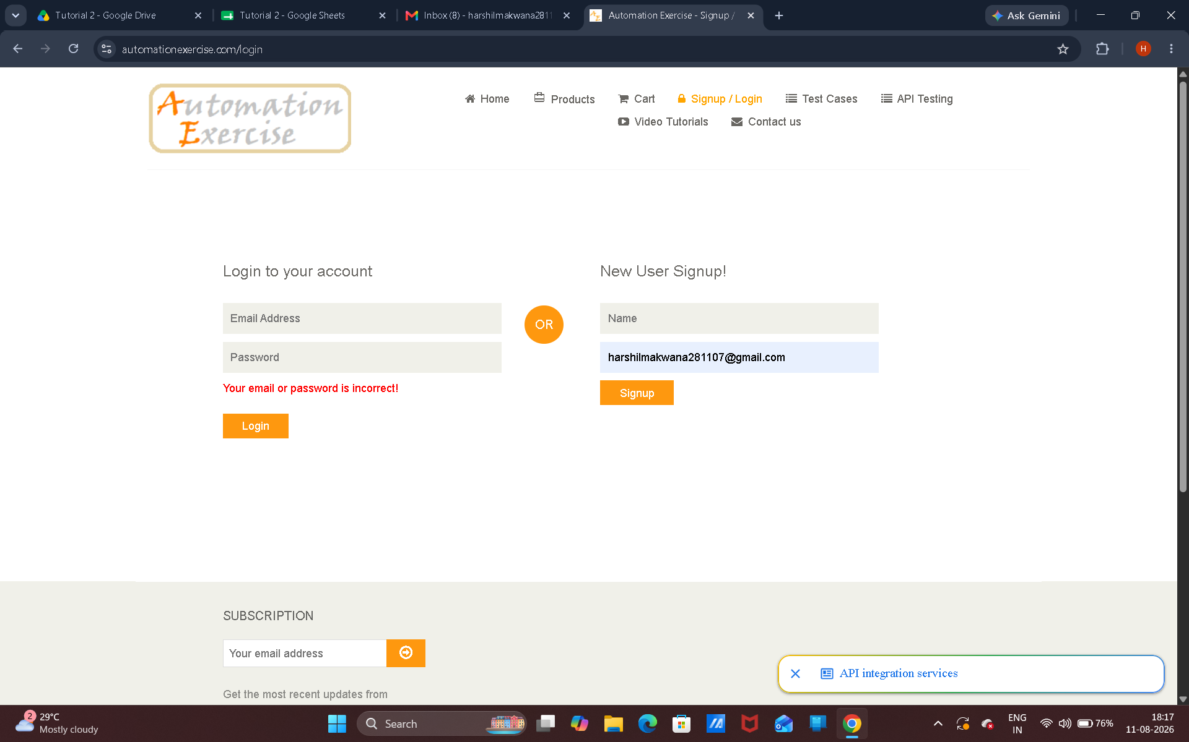

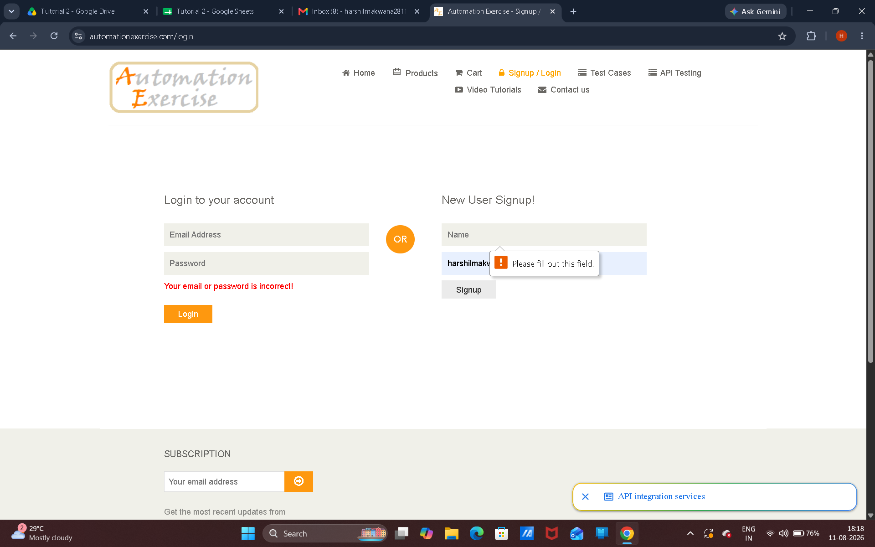

Scenario ID: 8
Scenario: Logout
Test Steps:
1. Open Home page
2.Go to logout option
Screenshots:

